Wise Words: A Few of My Favorite Things
Gary Wise
Thursday, December 20, 2001
"Raindrops on roses and whiskers on kittens" - Maria, the Sound of Music
You don't have to be a film student to have seen The Sound of Music. From as early in life as I can remember, I've had that movie on the memory banks as one of the first my parents ever showed me, and while I didn't fully grasp some of the larger issues the film dealt with, I could understand the basic underlying themes of freedom and the happiness it brings. One of the classic scenes in the film sees the lead character Maria singing the above line in listing 'a few of my favorite things'. In looking back now at those lines and being able to appraise them with many more years of experience on the books, I've come to one inescapable conclusion: Maria was a bit of a dork.

I've come to one inescapable conclusion: Maria was a bit of a dork.
I mean raindrops and whiskers? Come on. Give me a Mark McGwire home run or Morgan Freeman saying 'get busy living, or get busy dying' in The Shawshank Redemption. I may be taking some of nature's wonders for granted, but I think Dutch gamer Stan Van der Velden said it best: 'I've bungee jumped from 200 feet, but nothing gives me a kick like attacking for two', sorry Maria, but I take the little things for granted, and the things I choose to do are my favorites. That's why I play Magic.
There are a lot of things within this game I enjoy: the socializing, the travel, the constantly renewing questions and the constantly renewing quest for the answers to those questions... the list constantly renews itself thanks to the game's ever-changing nature. This week, I want to look at a few of those things that I really like in the game right now, and maybe just one that I'm pretty much indifferent to.

Casting Brainstorm
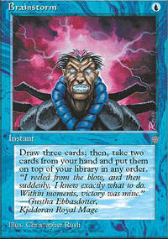
I've been telling anyone that will listen that Brainstorm is the best card in Extended, and while Call of the Herd, Oath of Druids, Pernicious Deed, Force of Will and Gaea's Blessing have every right to complain, I'm standing by that insistence (I know, there were 23 Calls in the Vegas Top 8, but hey, I'm stubborn). Once upon a time, Before Urza's Saga was released, Ancestral Recall was called by most 'the best card in Magic', and Brainstorm, used properly, doesn't fall too short in its attempt to emulate the similarly costed Type 1 card.
Obviously, Brainstorm won't be defining any environments any time soon because its strength is subtle in application, but the effect that strength produces at an extraordinarily low casting cost can't be ignored. Whether it's getting you out of a mana short opening hand, setting up your first few turns with the equivalent of a ten-card opening hand or sending your worst cards to the top of your library only to be shuffled away by Thawing Glaciers or Flood Plain, Brainstorm is always a welcome draw. At its worst, you have your mana, you've reached the top-decking mid-game and it gets you three cards further into your deck in hopes of finding a way to break a game open. That's a pretty good worst-case scenario.
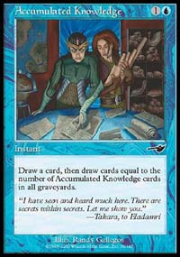
I recently found myself playing in my first weekend's worth of PTQs in four years with my qualification for Osaka uncertain (A Top 48 finish in San Diego will keep me on the train). In testing the environment before and after New Orleans, I noticed time and again that whenever I found myself with a Brainstorm in hand, I would be in good shape, singing its pre-resolution praises ("cast the best card in Extended") before hand, and yelling its post-resolution praises after drawing my three cards. With that in mind, when it came time to choose a deck to play for the PTQs, Menno Dolstra suggested to Ben Ronaldson and I that Thawing Glaciers was the key to the mirror match, and when our testing showed him to be right, the natural evolution of the deck was the addition of four Brainstorms, making the Thaws that much better.
Regardless of my result, the effect was staggering. Not only did the mirror become a joke, but the way the deck was played changed before my eyes. Where before it was all about Intuitioning for Accumulated Knowledge, now, with so many blue decks out there playing AKs, it changed, with the deck now seeing a two-pronged approach to card advantage, either using the AK engine or abusing the (four) Brainstorms with Merchant Scroll, Intuition and Thawing Glaciers to form the perfect hand with which to go off. In other words, thanks in part to the way I played it, 'Trix' became the 'Brainstorm' deck.
Force of Will and Call of the Herd are the most important cards in Extended. It seems like you can't build a successful deck without one or the other unless you call it 'Sligh' now, but for my money, Brainstorm's the card I most want in my deck. I'll probably play islands in Lisbon.

Mikey P's having a pretty good year.

Mikey P winning Grand Prix-Las Vegas
Mike Pustilnik is anything but conventional when it comes to the construction of his decks, be they Limited or Constructed, but you have to admit that he makes the quirks work for him. With a main deck Choke in tow, Mikey emerged victorious from a tough field in Las Vegas. Congrats to the evil doctor or whatever you'd call him. It couldn't happen to a nicer guy.

Reading Dan Paskins
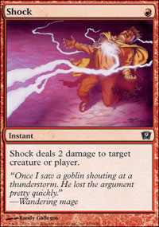
There are a lot of strategy articles on the net these days whose advice I'd say are almost detrimental, so when an author's comprehension of their subject matter reaches a certain level, they should be recognized.
Dan Paskins is a red player. For as long as anyone around here can remember, he's been casting one casting cost red creatures and burn spells and he's done it well. Now in university at Oxford, Dan's studies have superseded his Magic play, but he still finds the time to write on occasion about the merits of the red deck, be it called Sligh, RDW2K or what have you.
Quite often, when the subject matter of Magic articles takes an informed approach, the author will forget that at its base, Magic is a game whose design's purpose is fun before anything else. Paskins keeps things light while discussing the game, injecting his own brand of humor into his articles, which used to appear on Mindripper and are now found on Cutting Edge. Dan is definitely biased towards the red cards, but when you read him, do so with the understanding that he knows his stuff and is right more often than not. Just be careful not to fall into his traps: Most of us still wonder what the contents of Magdalin are.

Magic Online
As I write this, I've been playing Magic Online for a week and a half now and can say with certainty that I am an addict. Whether it is the understanding of the game the program possesses or just all the pretty pictures, the program satisfies just about every need I have as an online gamer short of being able to do invite-only drafts in preparation for Pro Tours.
I've seen a lot of complaints on the net of late defending Apprentice in the face of the Magic Online invasion, but I don't understand why peaceful co-existence isn't an option. Now in the beta testing, Magic Online isn't going to be free for ever (Not that I blame Wizards. Anything this good eventually has to have a price tag put on it), and while those who can afford will. Thanks to Apprentice, those who can't afford don't have to.
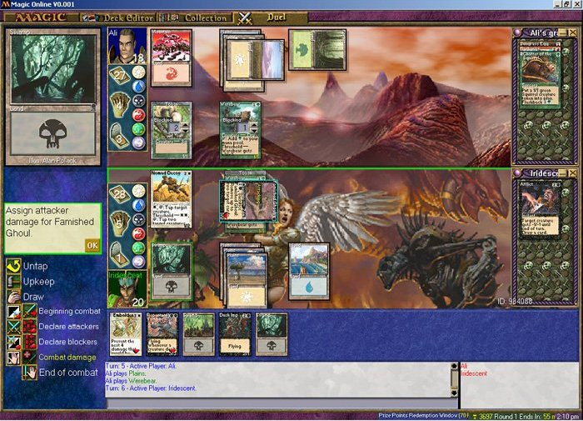
Apprentice and Magic Online provide two separate services. The former fulfills gaming fantasy, allowing us to have any cards we want in the blink of an eye, while at the same time providing a practical forum for online playtesting efforts. Magic Online meanwhile provides as good an online simulation as you could hope to find for sanctioned tournament play: It isn't built for practice, but to put all you've learned from playtesting INTO practice.
I think the two programs actually compliment one another very well, but while Apprentice will always provide certain needs of the online gaming community, it doesn't come with the glitz and glamour that Magic Online provides. Don't let the nay-sayers convince you of anything until you get to try it yourself: Magic Online is here to stay and worth your attention, if only to give it a chance. I allowed myself that moment of contemplation, and now I can't get enough.

Odyssey in Extended
Who was the moron who said this set sucks in Constructed? If they've stepped forward, have they been duly flogged for their incompetence? I once mentioned in this column that people were calling Odyssey the weakest set since Homelands, but I'm thinking that with the results of recent Grand Prix being what they've been, the world has seen the light of the set that may be the most revolutionary in years.
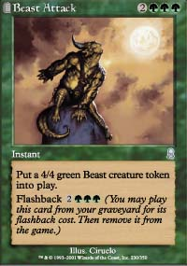
I'm not suggesting this is the most powerful set that's ever been made, but Odyssey has changed the way Magic is played in a way that no other set really has, opening up entirely new dimensions to the game, be it the card advantage involved in the creature-producing flashback cards like Call of the Herd and Beast Attack or the importance of the size of your graveyard inherent in threshold. The graveyard is now just as important as the hand, library or field of play.
Every time you peruse the Extended GP deck lists, you find new Odyssey cards finding their way into decks: From Call of the Herd, Shadowmage Infiltrator and Zombie Infestation to Werebear, Mystic Enforcer and the best squirrel ever, Krosan Beast. Every weekend, new archetypes emerge, and they all seem to be using one Odyssey card or another to function at their fullest. Next week, the Shrine deck will be in vogue. Two weeks from now, Delaying Shield.
The only reason I can see for people panning Odyssey is their failure to recognize that non-rares can be good. There are a lot of so-so cards to open in the rare slot, but the uncommons and commons are strong enough to make up for it when constructing your decks. Adding new dimensions to the game without subtracting the old ones only goes to increase Magic's skill level. The present game is classic Magic's equivalent of three-dimensional chess: There's just more to think about when making your decisions, and more ways to go about the task of finding the win.
Odyssey is great, be it for Constructed or Limited. In a few weeks time, PT-San Diego will take place, and after that it will be time to start looking towards Osaka and Odyssey Block Constructed. I'm surprised to find myself saying this, but I'm almost excited about getting to work on the format. Should be amazing.
Oh, and by the way, the reason I'll be working on it is because I won the aforementioned PTQ. You guys can put away the party hats and kazoos: the rumors of my demise have been greatly exaggerated. Have a good week.

